**PRACTICAL 5**

NAME - Lalit singh

COURSE -MCA 1st sem

ROLL NO -2351027

SUBJECT - Computer Networks Laboratory (PMC-102)

**OBJECTIVE: To demonstrate the difference between the switch and hub.**

**Procedure:**

**Step 1:** Select 8 pc from end devices then switch and hub from networking device section.

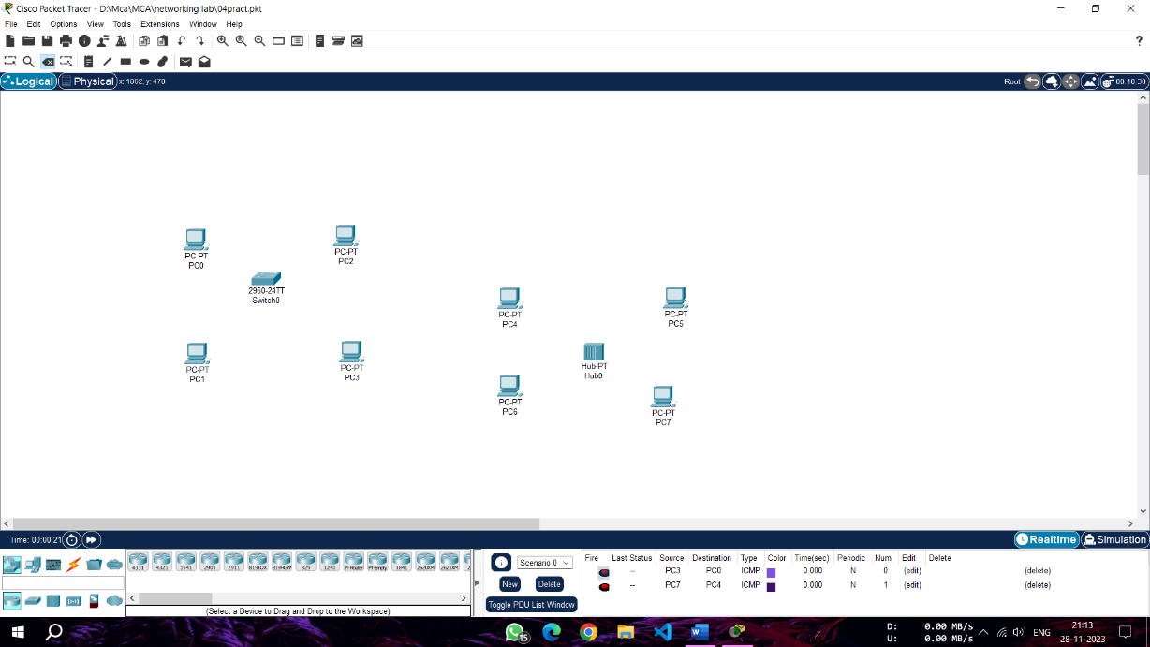

**Step 2:** connect the 4 pcs with switch and another pc with hub through ethernet port.

**Step 3:** Now select simple PDU message from the main toolbar section and drop it on any two pc which connected to switch.

**Step 4:** Now again select simple PDU message from the main toolbar section and drop it on any two pc which connected to hub.

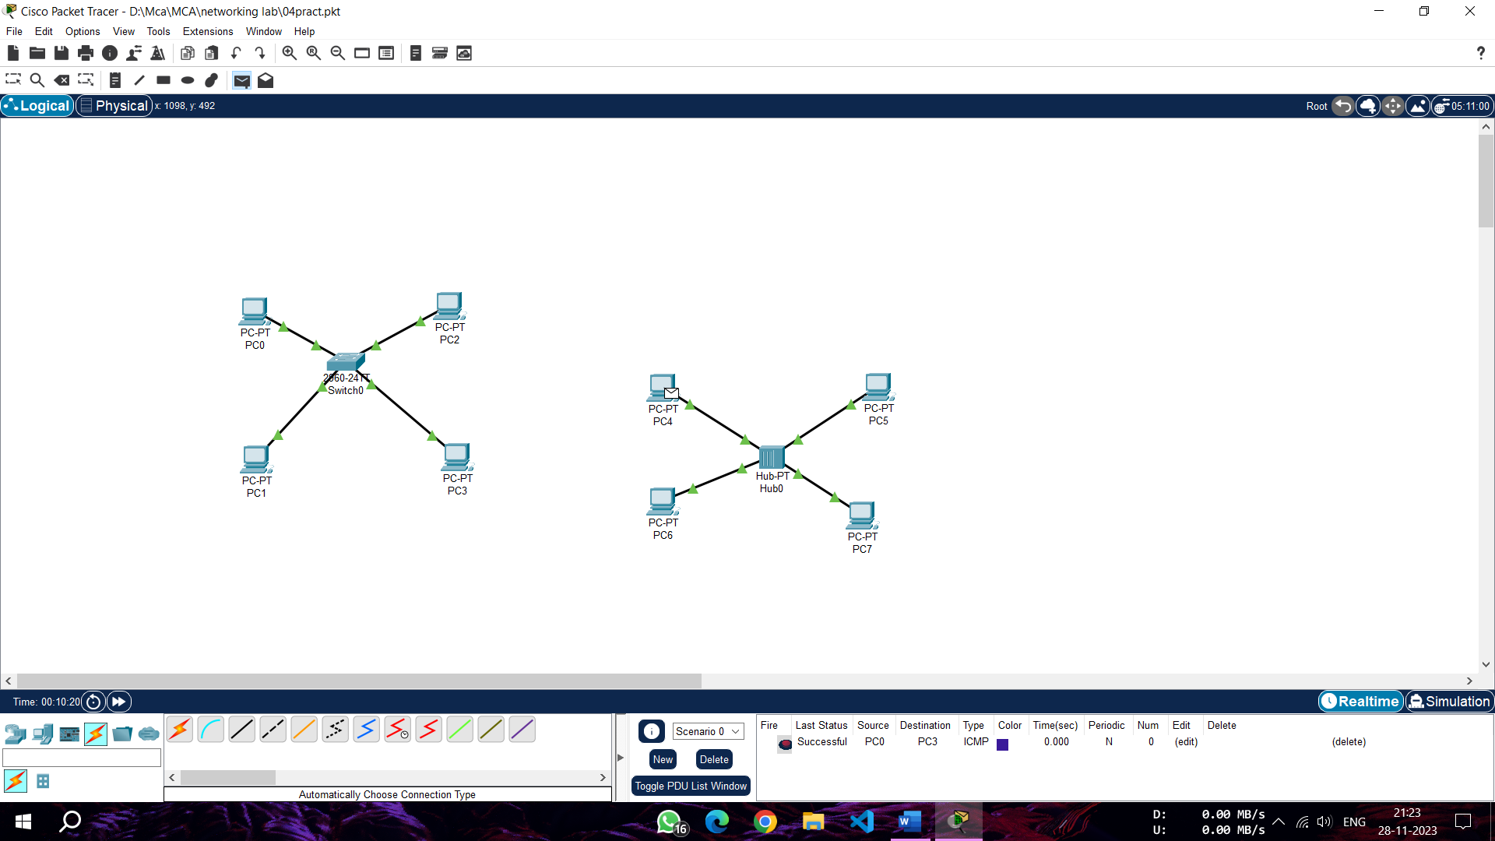

**Step 5:** Now click on simulate option from the bottom toolbar section, a simulate panel will open click on play option to simulate the data transfer of data.

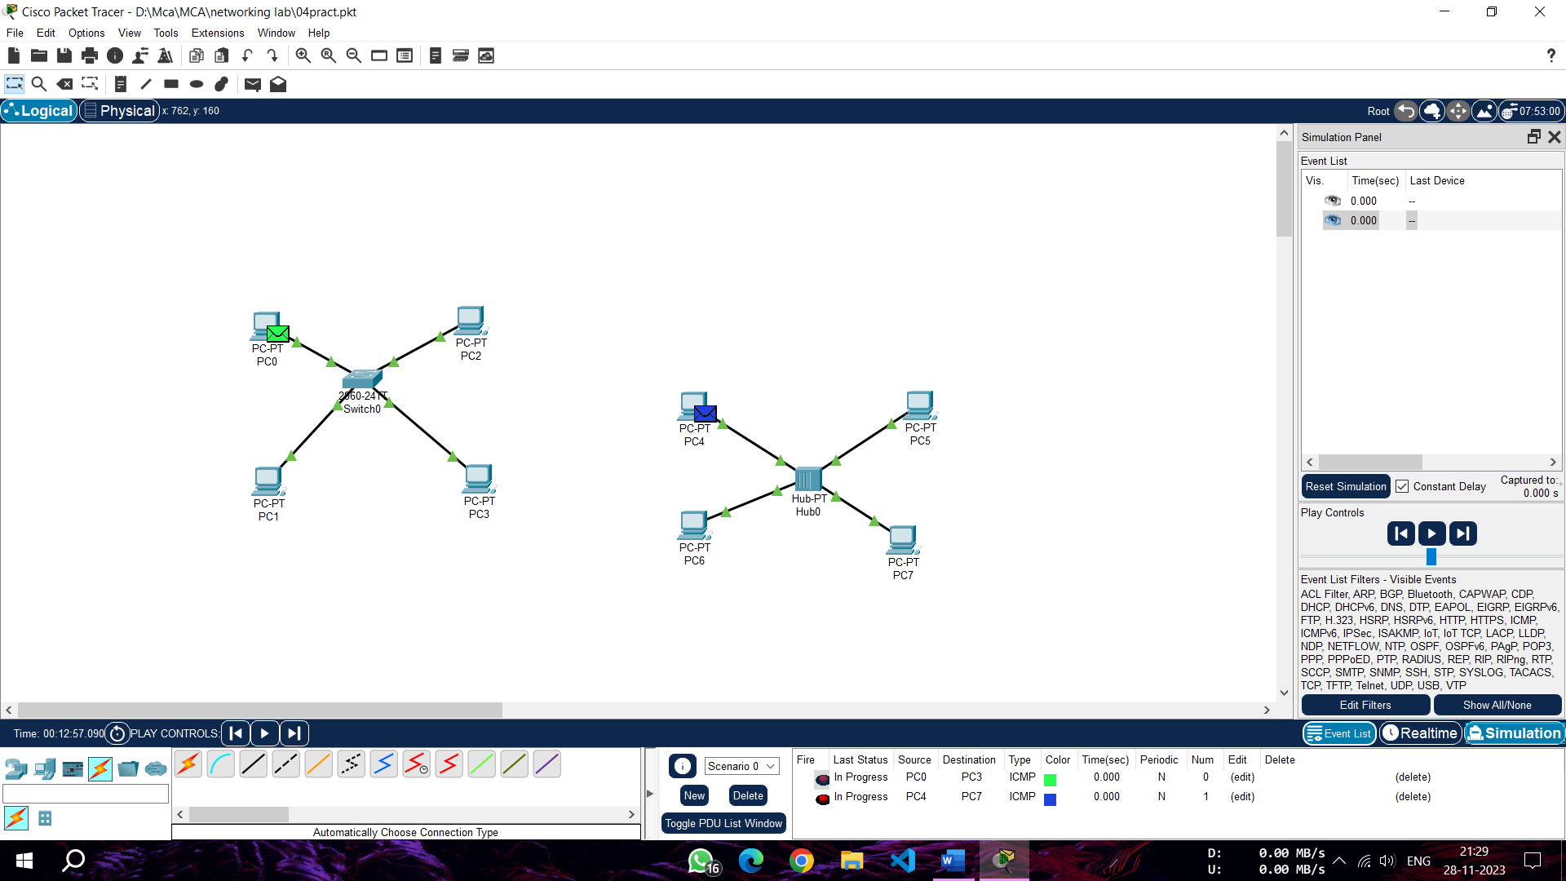

**Step 6:** A simulation will shows how PDU messege is sent to destination, in case of switch it will only sends the data to reciever but in case of hub it send the message to all pc and only accepted by reciever and rejected by other in network

